Health and Safety - General Risk Assessment

- Legal Requirement : Regulation 3 (1) of The Management of Health and safety Regulations 1999 requires that :

- “ Every employer shall make a suitable and sufficient assessment of -

- the risks to the health and safety of his employees to which they are exposed whilst at work; and

- (b) the risks to the health and safety of persons not in his employment arising out of, or in connection with, the
- conduct by him of his undertaking.

Risk Assessment procedure :

- Identify the area of assessment. List the tasks on the Summary sheet. Plan target dates for assessment.

Is the task unique to this area or does it apply to all, or several, areas (generic) ? Allocate generic tasks to nominated assessors to avoid duplication.

For each task :
- Identify the Hazards. Identify the people at risk (groups, numbers, special needs)

- Establish the existing control measures relating to each hazard. Obtain any supporting information, e.g. inspection sheets, test records, training records, other assessment records (Manual Handling, COSHH etc.), Safe Working Practices.

- Decide, at this stage, whether a more detailed assessment needs to be done for a specific hazard, e.g. noise, COSHH, Manual Handling, and record this as a recommendation.

- Evaluate the risk ( from likelihood and severity, number of people exposed and control measures in place.)

- Decide suitable control measures to remove or reduce risk ( use hierarchy). Discuss proposed control measures with the Supervisor, Safety Representative and employee to ensure they are practical and will control the hazard.

Make recommendations of additional control measures to further reduce risk.
Provide sufficient detail with the recommendations to clearly indicate what is required, giving rough estimates of cost if possible.

Record each task assessment on a separate sheet; sign and date all records, keep on file, arrange date for review.

Assessment Check Lists for Guidance

Identify all tasks to be assessed | Identify how task is done | Health and Safety Hazards | Control Measures
Identify boundaries of area under assessment. Include any ‘off-site’ locations.  Agree with neighbouring assessor. Ensure no gaps.  List all tasks to be assessed. using unique logical reference number for each.  Break larger jobs down into manageable tasks.  Ensure all jobs are covered, e.g. those done twice a year, routine out of normal hours, if a machine fails, in an emergency etc.  Include any cleaning (end of shift or ‘clean as you go’) tasks or any repair work carried out ;  who disposes of waste ?  Include any off-site work – driving, delivery, work on customer’s premises.  Re-check final list with Manager / Supervisor. | Involve employee(s) and Supervisor, question any differences. Is it a generic task ?  Progress logically through task, ask for demonstration.  Note details of machinery, tools, substances used. Is there a written Operating Procedure?  How many people carry out this task ? How often is it done ? How long does it last on each occasion. When is it done (normal hours, weekends, night, day, ‘rush hour’) ?  Are there any restrictions on operators ? Skills / qualifications required ? Authorisation required ? Restrictions on when done, or for how long ? | Machinery - Moving parts, sharp edges, stored energy (movement after power disconnected)  Electricity - Electric shock, burns, fires, secondary accidents (through being startled – e.g. falls from ladders)  Chemicals - Toxic, corrosive, harmful; flammable; skin or eye contact with chemical, inhaling vapour/dust, swallowing. (Has a COSHH assessment been carried out?)  Handling - Manually handling loads, stacking, loading, rapid repeated hand / arm movements. Have Manual Handling assessments been done ?  Vehicles - Fork Lifts, cranes, mobile platforms.  Working at height - falls, integrity of scaffolds / ladders, falling objects, windy/wet conditions.  Confined Spaces - toxic or suffocating gases, inrush of liquid or solid, temperature / humidity, availability of assistance, retrieving injured person.  Welding - Fumes, burns, ‘arc eye’, fire, explosion.  Public Places - Violence, distraction, interference with equipment, dogs, disregard of signs.  Underfoot Conditions - Slippy or damaged floors, obstacles or protruding items, other trip hazards, e.g. trailing cables, edges of mats. Deep steps, steep slopes.  Lighting - Poorly lit areas, e.g. stairs, yards, stores. Poor lighting maintenance/repair service, rapid changes in lighting levels for truck drivers, bright lighting obscuring vision.  Temperature - Effects of temperature extremes,  Ventilation - preventing build up of fumes / gases, condensation.  Noise – do people have to communicate in raised voices ? Are any machines / tools particularly noisy ? Have noise surveys been done ?  Vulnerable persons – special needs catered for ?, e.g. pregnant women, young persons, disabled persons. | Elimination – does the task have to be done? Can it be contracted out?  Substitution – can a safer  method / substance be  used ?  Enclosure / Isolation /  Extraction – can hazard  be screened off, guard /  trip / alarm fitted ? Can  persons be separated from  hazard or reduce duration  exposure ? (job rotation).  Is extraction or flushing  required to remove harmful  agents ?  Personal Protection –  always as a last resort.  What type is needed ?  What grade is needed ?  Assess with advice from  suppliers.  Training – is special  training required. Do signs  need to be posted?  Other considerations :  Welfare facilities,  First Aid facilities  Emergency Procedures  Is a more detailed  assessment required ?  e.g. COSHH, Noise

The above check lists are not exhaustive and should only be used as a guide

Risk Rating Procedure

Likelihood of Incident Occurring (L) Severity of Incident (S)

Likelihood Example Timescale Severity Example Injury

10 Inevitable 10 Every shift 10 Multiple Fatalities 10 Fatalities

9 Almost Certain 9 Once a week 9 Permanent / total 9 Brain damage/ total disability/
incapacity / fatality death
8 Very probable 8 Twice a month 8 Permanent, severe incapacity 8 Loss of limb or eye/ part
disability

7 Probable 7 Once a month 7 Permanent slight incapacity 7 Permanent limp/ back injury

6 More than even chance 6 Once a quarter 6 Off work for more than 3 weeks 6 Limp/ repetitive strain
with subsequent recurring injuries
incapacity

5 Even chance 5 Twice a year 5 Off work for more than 3 weeks 5 Broken bone/ trap injuries/
with subsequent complete recovery respiratory problems

4 Less than even chance 4 Once a year 4 Off work more than 3 days, less 4 Head injury/ concussion/
than 3 weeks with subsequent sprains/ pulled muscles/
complete recovery serious burns/ dermatitis/
eye contamination

3 Improbable 3 Once in two years 3 Off work for less than 3 days with 3 Minor burns/ stitches needed/
complete recovery exposure to fumes/ foreign
bodies in eyes/ skin irritation

2 Very improbable 2 Once in five years 2 Minor injury, no lost time 2 Bruise/ small cut/ blister
grazes/ bump

1 Almost impossible 1 Once in ten years 1 No significant injury 1 Very minor cut/graze, shaken

Population at Risk (at any one time) Weighting :
(add weighting to Severity Rating) 1 – 5 people 1.0 , 6-10 people 1.25 , 11-20 people 1.5 , 21-50 people 1.75 , >51 people 2.0
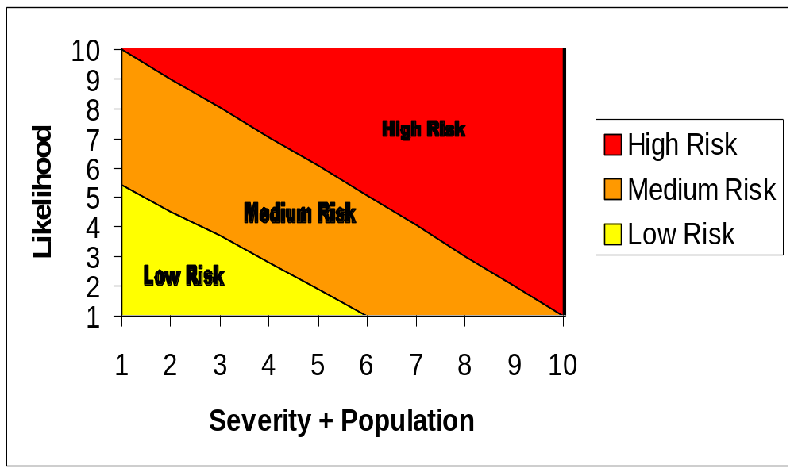 Risk Assessment Rating Procedure - Level Calculation Matrix

Plot value of Severity + Population from assessment against value of Likelihood from assessment.

The point of intersection of these two values gives the Risk Level.

